Exp no:8
Determination and plotting of Magnetic Field Intensity, Intrinsic Impedance and Phase Velocity in different medium.
Aim:
To write program for determination and plotting of Magnetic Field Intensity, Intrinsic Impedance and
Phase Velocity in different medium using MATLAB.
Software required:
•MATLAB (R2018 or later)
Test case (i) Determination and plotting of Magnetic Field Intensity due to infinite long conductor at a distance r
Program:
clc;
clear;
I = input('Enter the current (A):');
r = input('Enter the distance (m):');
mu0 = 4*pi*1e-7;
H = I/(2*pi*r);
disp('Magnetic Field Intensity is');
disp(H);
% Plot
x = linspace(0.1,10,100);
H_plot = I./(2*pi*x);
figure;
plot(x,H_plot,'LineWidth',2);
xlabel('Distance (m)');
ylabel('Magnetic Field Intensity (A/m)');
title('Magnetic Field Intensity vs Distance');
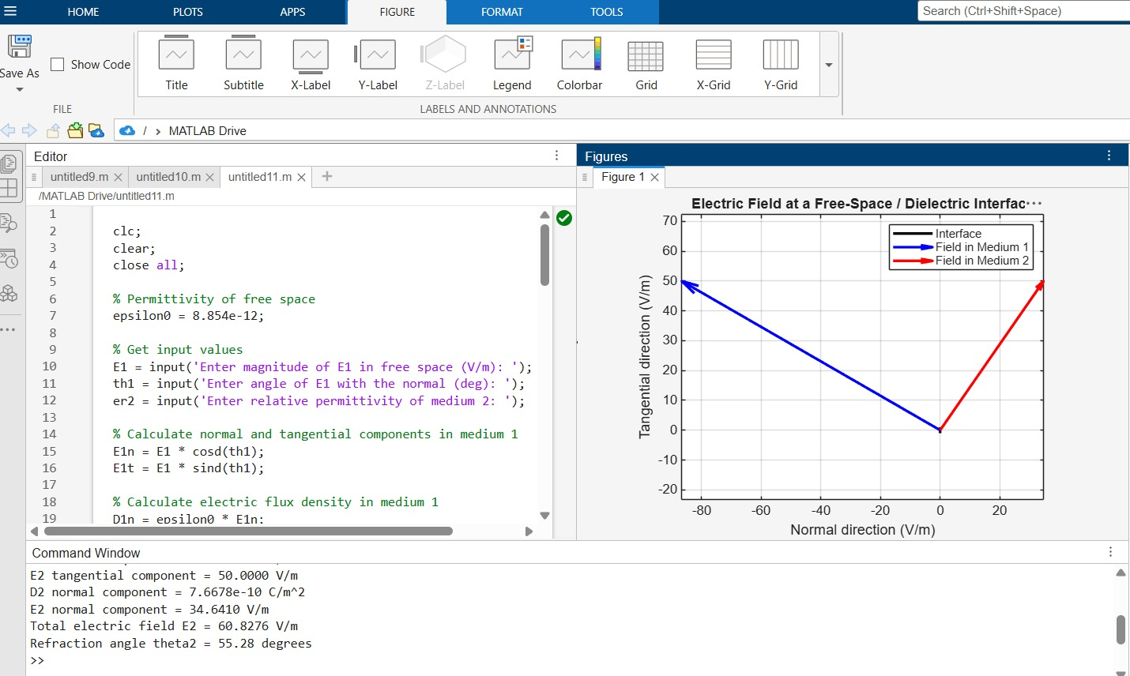
Test case (ii) Determination and plotting of Magnetic Flux Density in free space
clc;
I = 5;
mu0 = 4*pi*1e-7;
r = linspace(0.1,10,100);
H = I./(2*pi*r);
B = mu0 * H;
plot(r,B,'LineWidth',2);
xlabel('Distance (m)');
ylabel('Magnetic Flux Density (T)');
title('Magnetic Flux Density vs Distance');
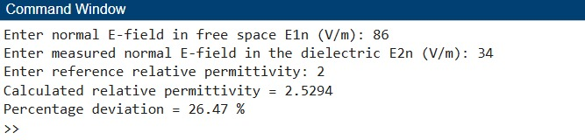

Test case (iii) Determination and plotting of intrinsic impedance for different media
clc;
mu0 = 4*pi*1e-7;
epsilon0 = 8.854e-12;
er = linspace(1,5,100);
ur = linspace(1,2,100);
eta = sqrt((mu0.*ur)./(epsilon0.*er));
plot(er,eta,'LineWidth',2);
xlabel('Relative permittivity');
ylabel('Intrinsic Impedance (Ohms)');
title('Intrinsic Impedance vs Permittivity');
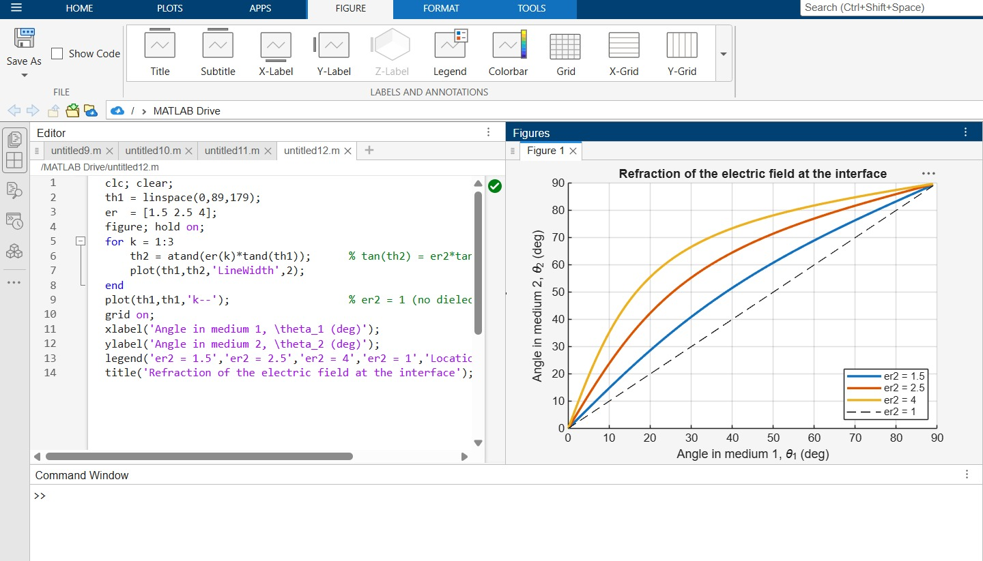
Result :
Thus the program was verified for magnetic field intensity, intrinsic impedance and phase velocity in different medium using MATLAB was successfully.
